Please provide this Direct Deposit Authorization Form to your employer to establish automatic deposit.

EMPLOYEE INFORMATION

Name:

ACCOUNT INFORMATION

Deposit Amount: Full Paycheck Partial Amount:
Bank Name: Continental Bank Bank Routing / ABA Number: 124003077
Bank Address: 15 W. South Temple Ste 300 City, State, Zip: Salt Lake City, UT 84101
Bank Phone Number: 801-595-7000
Account Number: Type of Account: Checking Savings
Account Name:

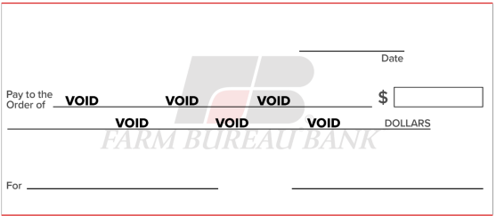

AUTHORIZATION

I authorize (company name) and my bank to automatically deposit my paycheck into my account listed above (this includes my authorization to correct entries made in error). This authorization will remain in effect until I give written notice to cancel it.

Signature: Date:

